EXAMPLE ON PRISM

A glass prism of angle 72° and index of refraction 1.66 is immersed in a liquid of refractive index 1.33. What is the angle of minimum deviation for a parallel beam of light passing through the prism?

Solution:

n = sin $[\frac{A+Dmin}{2}]$/ sin $\frac{A}{2}$

where n is the relative refractive index of glass with respect to the liquid.

But n = 1.66/1.33

Therefore, 1.66/1.33 = sin $[\frac{72+Dmin}{2}]$/ sin $\frac{72}{2}$

= sin / sin 360

This implies that sin = 1.66/1.33 sin 360 = 0.7335

= 47.10

Therefore, Dmin = 22.2°

**Dispersion. Spectra. Chromatic Aberration**

In 1666, Newton made a great scientific discovery. He found that sunlight, or white light, was made up of different colours, consisting of red, orange, yellow, green, blue, indigo, violet. Newton first made a small hole in a shutter in a darkened room, and received a white circular patch of sunlight on a screen in the path of the light. He then placed a glass prism between the hole A and the screen S, and on moving the screen round as shown in Fig. 1 (i), he observed a series of overlapping coloured patches in place of the white patch,

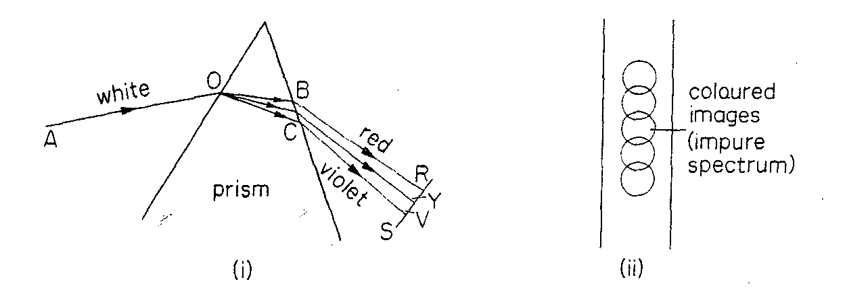

**Fig. 1 Impure spectrum (diagrammatic)**

The total length of the coloured images was several times their width, Fig. 1 (ii). By separating one colour from the rest, Newton demonstrated that the colours themselves could not be changed by refraction through a prism, and he concluded that the colours were not introduced by the prism, but were components of the white light. The spectrum (colours) of white light consists of red, orange, yellow, green, blue, indigo and violet, and the separation of the colours by the prism is known as **dispersion.**

The red rays are the least deviated by the prism, and the violet rays are the most deviated, as shown in the exaggerated sketch of Fig. 1 (i) for one typical ray in the incident beam. Since the angle of incidence at 0 in the air is the same for the red and violet rays, and the angle of refraction made by the red ray OB in the glass is greater than that made by the violet ray OC, it follows from sin i/sin r that the refractive index of the prism material for red light is less than for violet light. Similarly, the refractive index for yellow light lies between the refractive index values for red and violet light.

**Production of Pure Spectrum**

Newton’s spectrum of sunlight is an impure spectrum because the different coloured images overlap Fig 1 (ii). A pure spectrum is one in which the different coloured images contain light of one colour only, i e they are monochromatic images. In order to obtain a pure spectrum (i) the white light must be admitted through a very narrow opening so as to assist in the reduction of the overlapping of the images (ii) the beams of coloured rays emerging from the prism must be parallel so that each beam can be brought to a separate focus.

**Achromatic lenses**

When white light from an object is refracted by a lens, a coloured image is formed. This is because the glass refracts different colours such as red, r, and blue, b, to a different focus (Fig. 2). The coloured images are formed at slightly different places and this is called the chromatic aberration (colour defect) of a single lens.

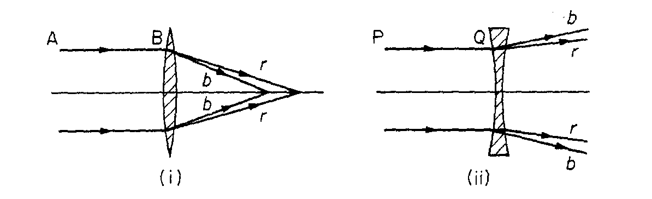

**Fig. 2 Dispersion produced by converging and diverging lens**

A converging lens deviates an incident ray such as AB towards its principal axis, Fig. 2 (i). A diverging lens, however, deviates a ray PQ away from its principal axis, Fig. 2 (ii). The dispersion between two colours produced by a converging lens can thus be neutralised by placing a suitable diverging lens beside it. Two such lenses which together eliminate the chromatic aberration of a single lens are called an achromatic combination of lenses. Fig 3 illustrates an achromatic lens combination, known as an achromatic doublet.

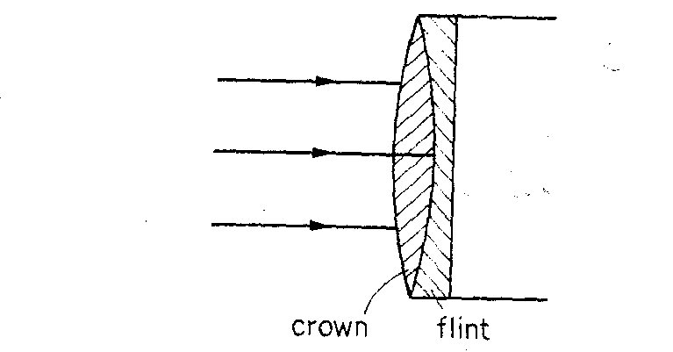

**Fig. 3 Achromatic doublet**

The biconvex lens is made of crown glass, while the diverging lens is made of flint glass and is a pIano-concave lens. It should be noted that chromatic aberration would occur if the diverging and converging lenses were made of the same material, as the two lenses together would then constitute a single thick lens of one material.

**Condition for achromatic lenses.**

Since 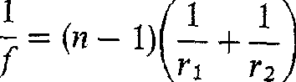 with the usual notation, with blue and then red light we have

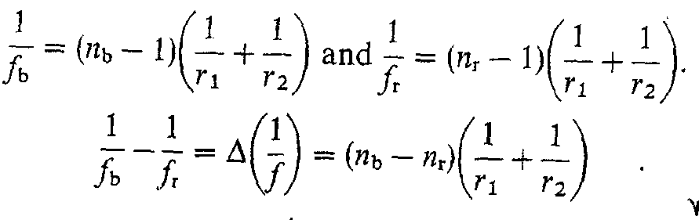(i)

So

Where 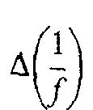 is the small change in  when blue, and then red, rays are incident on the lens.



Where f is the focal length of the lens when yellow light is incident on the lens, and n is the refractive index for yellow light. Dividing (i) by (ii) and simplifying, we obtain

∆1/f = nb – nr/n-1 x1/f = w/f (iii)

Hence, the dispersive power of a material for the two colours is defined by

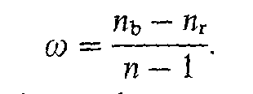

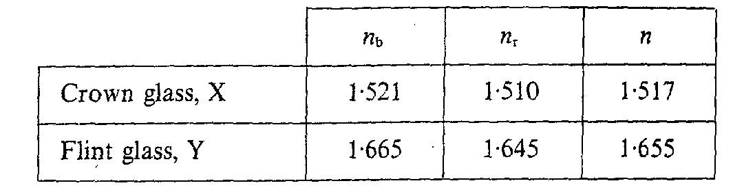

For a certain crown glass, nF = 1521, nc 1510 and np = 1517. Hence, for the F(blue) and C(red) lines,

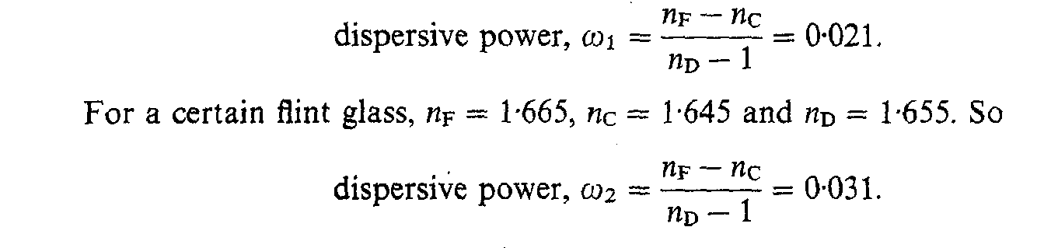

So the flint glass has about 15 times the dispersive power of the crown glass.

Suppose f1, f2 are the respective focal lengths of two thin lenses in contact, w1, w2 are the corresponding dispersive powers of their materials, and F is the combined focal length. If the combination is achromatic for blue and red light, the focal length Fb for blue light is the same as the focal length Fr, for red light, that is, Fb = Fr.

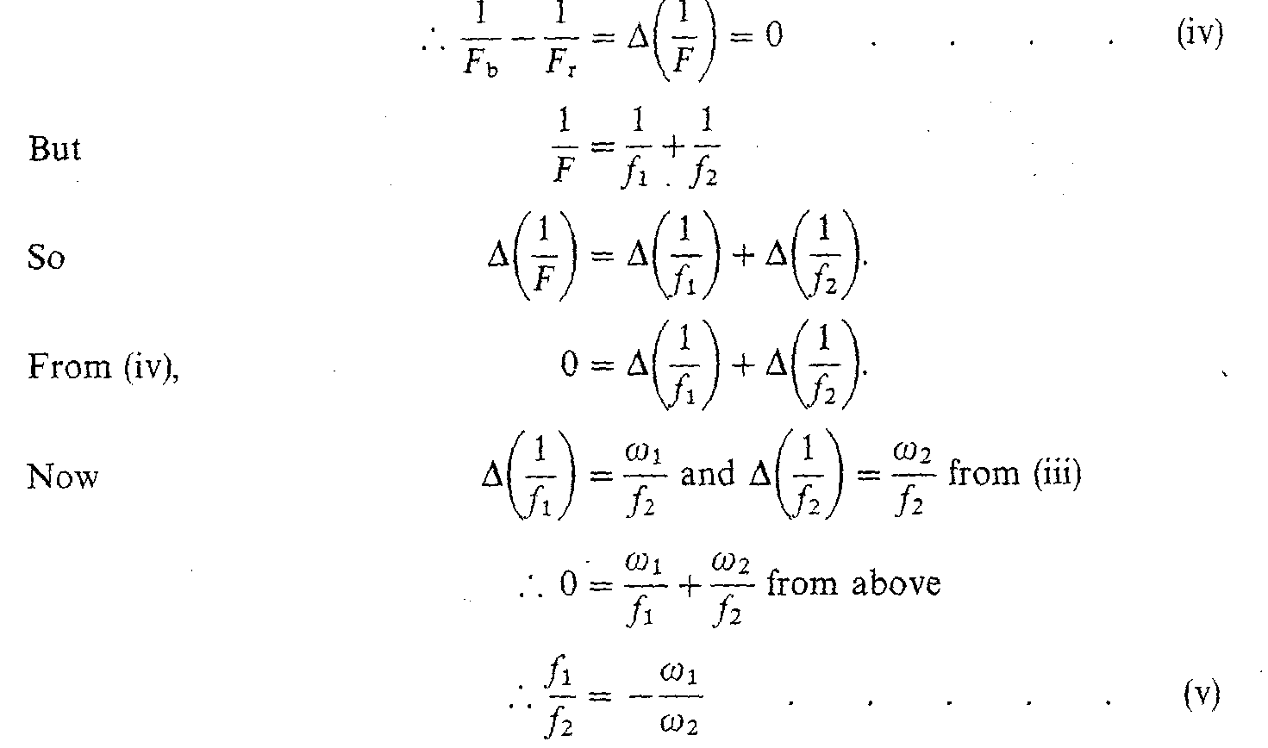

Thus the ratio of the focal lengths is equal to the ratio of the dispersive powers of the corresponding lens materials. Since to w1, w2 are positive numbers, it follows from (v) that fi and f2 must have opposite signs. So a diverging lens must be combined with a converging lens to form an achromatic combination as shown in Fig. 3.

EXAMPLE

A convex lens whose two faces have the same radius of curvature has a focal length of 16cm. The refractive index of the glass is 1.52. Find the radius of curvature.

Solution

1/f = (n – 1)(1/r1 + 1/r2)

But r1 = r2

Therefore, 1/16 = (1.52 – 1) 2/r1

r1 = r2 = 16.64cm